Module Code: FC723
Class/Group: A
Module Title: Programming Theory
Assessment Title: FC723 Final Project
Tutor Name: Sophie Norman
Student GUID Number: P491908
Date of Submission: 5 July 2026

I confirm that this assignment is my own work.
Where I have referred to academic sources, I have provided in-text citations and included the sources in the final reference list.

Part A Q1: Software Development Process

Part A Q3: Activity Diagram
Figure 1: Activity Diagram for Apache Airlines Seat Booking System
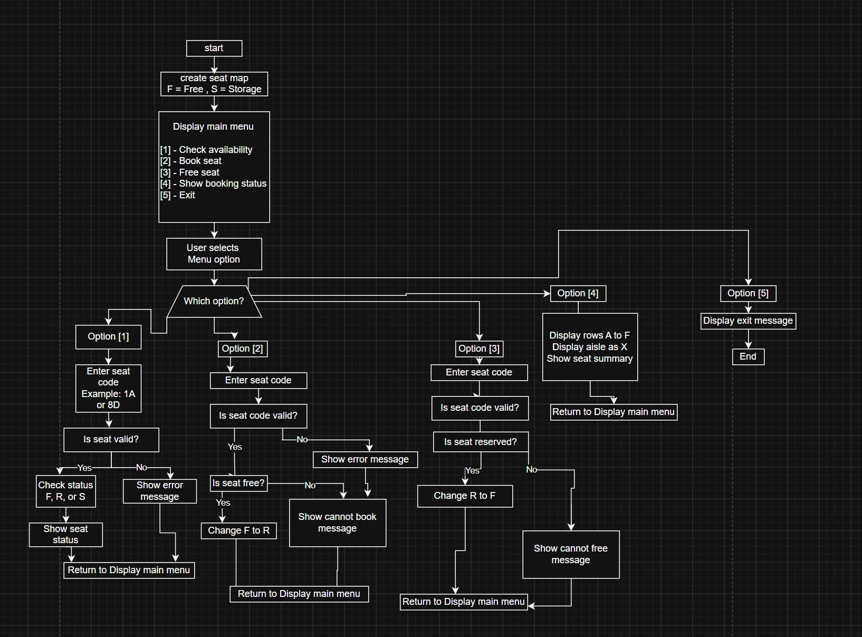
This activity diagram shows the flow of the Apache Airlines seat booking system. The program starts by creating the seat map and then displays the main menu. The user can choose to check seat availability, book a seat, free a seat, show the booking status, or exit. After each action, the system returns to the main menu unless the user chooses the exit option.

Part A Q5: Additional Airline Functionality
Part A Q6: GitHub Version Control
Part B: Refactored System with Booking References and Database
Part C: 1000-word Essay with UML Diagrams

